**CSE3011 NETWORK PROGRAMMING**

**LAB EXPERIMENT 6**

NAME – B PRATYUSH

REGISTRATION NUMBER – 19BCN7114

LAB SLOT – L43+L44

FACULTY – PROF. MUNEESWARI

**Experiment**

1. **Source Viewer**
2. **Read And write to files using Streams**

**Code:**

**SrcViewer.java**

**package** lab6;

**import** java.net.*;

**import** java.io.*;

**import** java.util.*;

**public** **class** SrcViewer {

**public** **static** **void** main(String[] args) {

// **TODO** Auto-generated method stub

System.***out***.println("Enter url");

Scanner sin=**new** Scanner(System.***in***);

String url=sin.next();

**if**(url.length()>0)

{

InputStream in=**null**;

**try**

{

URL u =**new** URL(url);

in=u.openStream();

in=**new** BufferedInputStream(in);

InputStreamReader r =**new** InputStreamReader(in);

**int** a;

**while**((a= r.read()) != -1)

{

System.***out***.print((**char**) a);

}

}

**catch**(MalformedURLException e)

{

System.***err***.println(url + " is not a parseable URL");

}

**catch**(IOException e)

{

System.***err***.println(e);

}

**finally**

{

**if**(in!=**null**)

{

**try**

{

in.close();

}

**catch**(IOException e)

{

}

}

}

}

sin.close();

}

}

**Output:**

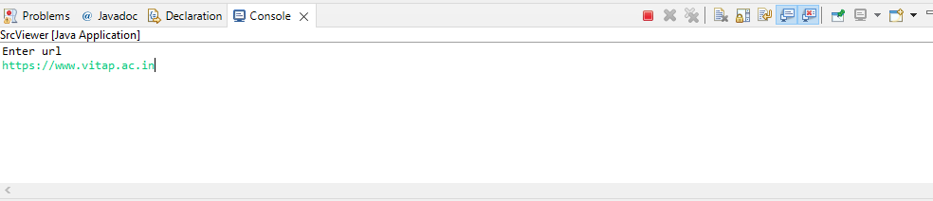

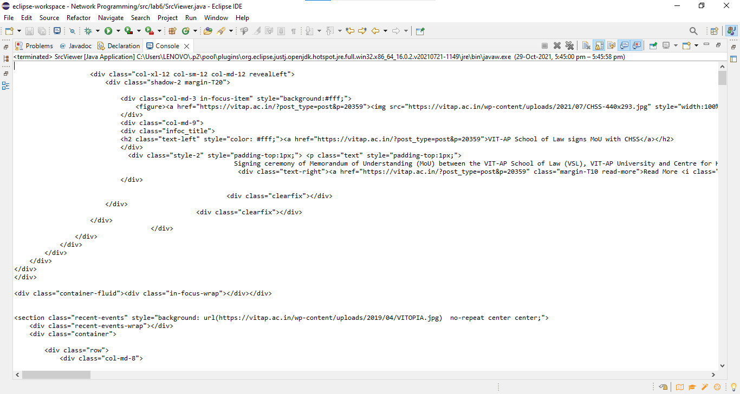

**Code:**

**ReadWriteFile.java**

**package** lab6;

**import** java.io.*;

**import** java.util.*;

**public** **class** ReadWriteFile {

**public** **static** **void** main(String[] args) {

// **TODO** Auto-generated method stub

**try**

{

System.***out***.println("Enter the input file name");

Scanner sin=**new** Scanner(System.***in***);

String infile=sin.next();

File input =**new** File(infile);

//Output file out.txt if existing will be updated or a new out.txt file will be created and info.txt will be copied it

File output =**new** File("out.txt");

//FileInputStream to read the input stream from input file created

FileInputStream fin=**new** FileInputStream(input);

//FileOutputStream to write data to out.txt created

FileOutputStream fos=**new** FileOutputStream(output);

**int** a;

//reads input until the stream is empty and then writes it to the output stream

**while**((a=fin.read())!= -1)

{

fos.write(a);

}

//Flushing the input and output file streams to avoid data leakage

fin.close();

fos.close();

}

**catch** (FileNotFoundException e)

{

System.***err***.println("File Not Found Exception: " + e);

} **catch** (IOException e)

{

System.***err***.println("IOException: " + e);

}

}

}

**Output:**

**Info.txt**

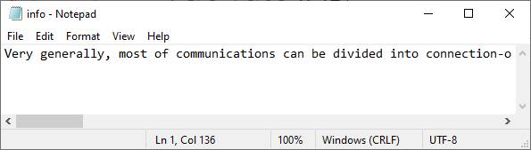

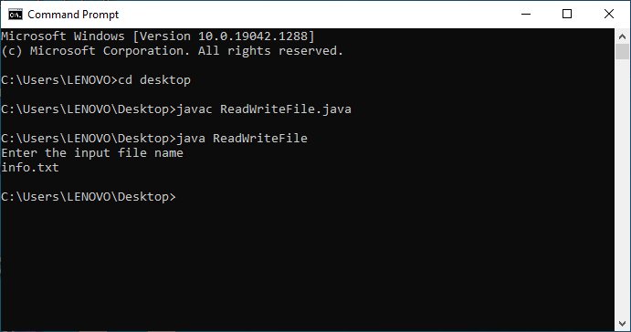

**Out.txt**

